**July 2024**

**Works notice – Flemington housing site**

Changes to car parking on Holland Court, Flemington

Homes Victoria, together with project partner Building Communities, is redeveloping the Holland Court, Flemington housing site to provide 286 social and affordable homes that are modern, accessible, and sustainable as well as a large new public park. The builder at the site is ICON.

**Changes to car parking on Holland Court from Friday 12 July 2024**

* From Friday 12 July 2024, most car parks along Holland Court, Flemington will be closed to allow access for construction vehicles.
* The car parks will be closed until the new homes are complete from late 2026.
* There will be barriers to show which car parks are closed.
* Residents and visitors will still be able to drive and walk along Holland Court and use other available car parks in and around the Flemington housing site.
* Relevant approvals have been obtained from Moonee Valley City Council for these car park closures.

Please see the map on the next page to see where car parks will be closed on Holland Court.

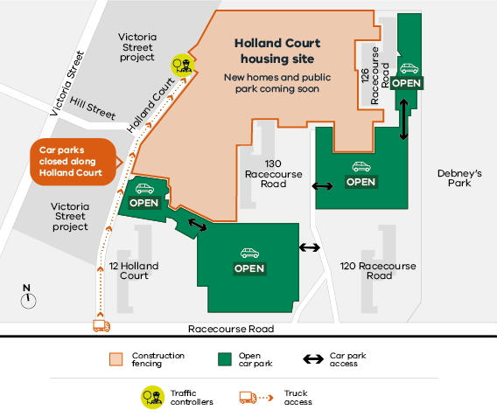

**ICON has a 24-hour hotline and email for residents**

We know that living near a construction site is not easy and we want to thank residents in Flemington for their understanding whilst we continue to work to address car parking issues at the Flemington housing site.

If you have any questions or concerns about the Holland Court, Flemington housing project, please contact ICON’s 24-hour resident hotline on **(03) 9389 3619** or email [**community.questions@icon.co**](mailto:community.questions@icon.co)

You can also contact Homes Victoria by email at [**flemington@homes.vic.gov.au**](mailto:flemington@homes.vic.gov.au)

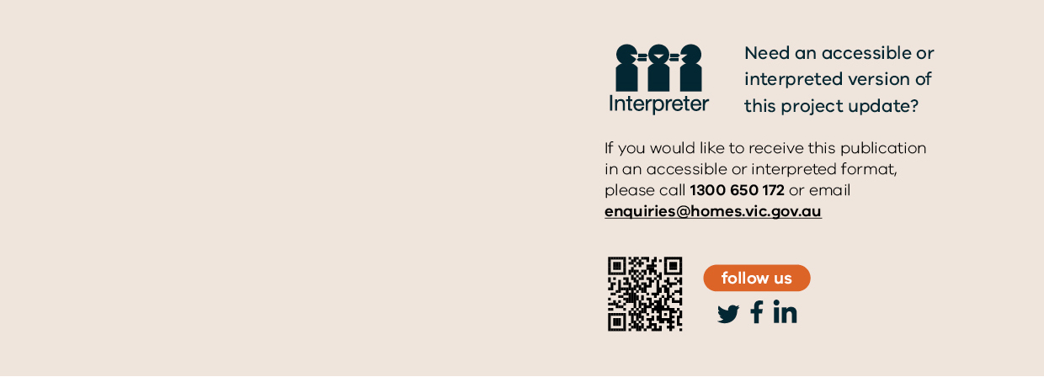

##### Further information

For more information please visit: **www.homes.vic.gov.au/holland-court-flemington.**

Authorised and published by the Victorian Government, 1 Treasury Place, Melbourne. © State of Victoria, Australia, Homes Victoria, July 2024.